Safarov Behzod

(Age 20 born on 1- April 2002)

Tashkent, Uzbekistan | (+998) 91-238 46 25 | behzodsafarov73@gmail.com







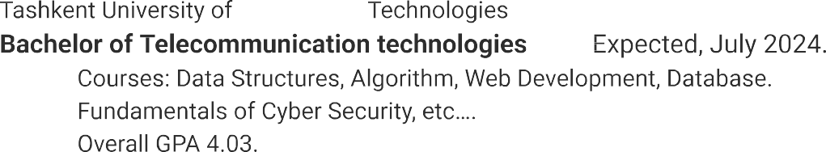



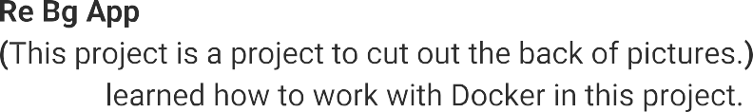







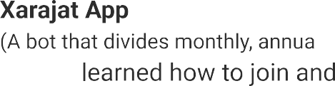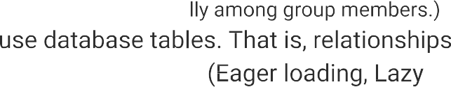

 





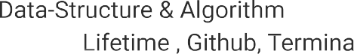





 GitHub: https://github.com/BehzodSafarov









